20F-0281
20F-0326
20F-0197
MARKETING MANAGEMENT
FINAL PROJECT

Contents
WATER FILTRATION PLANT 2
Need of the product 2
Situation Analysis 3
SWOT 3
Strengths 4
Weaknesses 5
Opportunities 5
Threats 5
PEST 6
Political: 6
Social: 6
Technological: 7
Economical: 7
Market Analysis 8
Segmentation 8
Targeting 9
Differentiation 9
Positioning 9
Four P’s 10
Product 10
Price 10
Place 11
Promotion 11
Business Analysis 12
Promotional budget 12
Projected income statement for 03 years 13

WATER FILTRATION PLANT
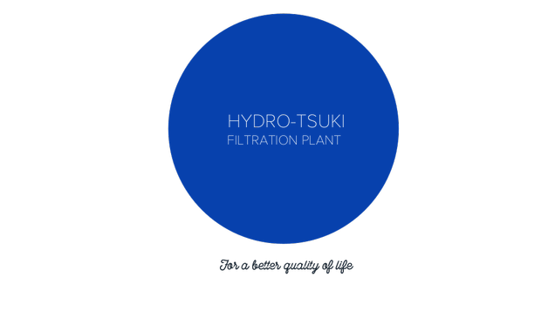

Need of the product

Water scarcity creates hygiene problems forcing people to drink unsafe water. When there is a deficiency of water, people tend to store it at their places, which increases the risk of water contamination in the home and creates breeding grounds for mosquitoes, which transmit dengue and malaria. Lack of water causes many other diseases such as trachoma (an eye infection that can cause blindness), plague, and typhus. In poorer countries, some children cannot go to school because they are either too sick or must walk a long time to reach a source of water. Even when they can participate, many children cannot learn due to their fatigue, heavy responsibilities, and worries for their families. In developing nations, around 80% of sicknesses are connected to poor water and sanitation conditions. 1 out of each 5 deaths under the age of 5 around the world is due to a water-related infection. Clean and secure water is fundamental to healthy living. Most of these waterborne illnesses aren't found in developed nations since the modern water frameworks that channel and chlorinate water to dispose of all infection-carrying organisms. But typhoid fever, cholera, and numerous other illnesses still run uncontrolled within the developing parts of the world. Potentially each glass of impure water can kill a person.
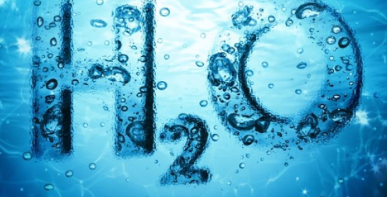
So, taking these points into consideration, we offer a product that can filter the polluted water and even clean dirty water. Hydro-Tsuki filtration plant aims to improve the clean water conditions of third-world countries and contribute to their bright future. Our team works day and night to achieve its goal of making the world a healthier place to live. The availability of safe and clean drinking water, which is a vital natural resource, is still a distant dream to many around the world, especially in developing countries. But our compact filtration plant will help backward areas with not many facilities and huge water filtration infrastructure to provide clean water for everyone. It filters the water thoroughly, including a better taste, and is more cost-effective and environmentally friendly when compared to buying bottled water. Water filtration is important because it gives people access to clean water that is free of contaminants and pollutants specs, it changes the water into something that tastes good, and is a reliable source of hydration. Without it, there’s the risk of becoming ill from contaminated water or the alternative of drinking other beverages that may not be as good for your health as purified water.

Situation Analysis

SWOT

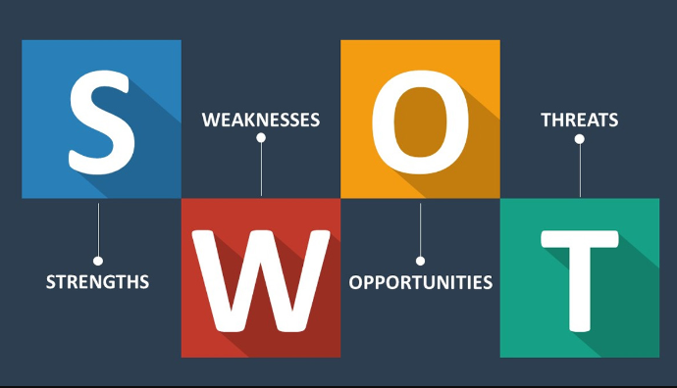
The following SWOT analysis captures the main strengths and weaknesses within the company and describes the opportunities and threats being faced by the company.

Strengths:
- Our company produces unique products that are not yet available in the market. Pure H2O is a very solid service company that makes it easy for its clients. We offer quality products within a reasonable range.
- A wide range of personal contacts.
- Quality Products.
- The service of the plant is simple and requires bare minimum equipment.
- The filtration system is portable and small and can easily be installed in any location without much issue.
- It is easy to install at any location without much effort needed.
- The user of the product does not have to incur substantial capital costs to install the filtration plant into their houses and companies. As it is small in size.
- There is no need for experienced and well-trained technicians to operate and maintain the plant. It is relatively easier to use and operate.
- A very strong corporate culture based on services.
- Hydro-Tsuki is providing high-quality water filtration systems that are far more economical than traditional bottled water. Hydro-Tsuki will offer customers many important benefits.
- Customer Satisfaction: This element of the marketing mix will be attended to with the utmost attention. One of the main premises of the business model is generating sales based on previously established trust relationships. Therefore, Hydro-Tsuki will ensure total customer satisfaction to safeguard future sales as well as the relationship.

Weaknesses:
- Currently a limited product line.
- Does not have the ability to meet the particular needs of the client.
- Large expenses are necessary for the development of the global network of distributors.
- The filtered water provided will be for a certain capacity. The water cannot be filtered more than its capacity.

Opportunities:
- The enormous diversification of potential clients. Multi-tier business model that generates multiple sources of income from associates. Clients are usually personal contacts with established bonds of trust.
- Personal Service: All interactions will be with the salesperson at a friendly, personal level.
- Growing competition in the market.

Threats:
- Established network of marketing organizations.
- A change in public perception of contacts with already formed trust ties.
- Change is technologies. More advanced and easy-to-use technology might affect the current users of technology.
- Competition from a larger company that decide to be more flexible to its customers.

PEST

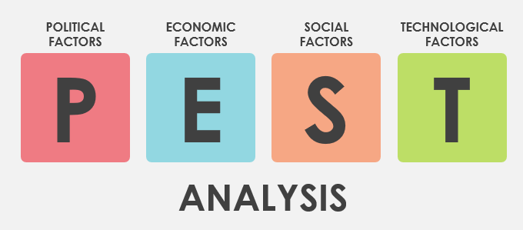

PEST analysis is often linked to SWOT analysis; however, the two tools have different areas of interest. PEST analysis examines the "big picture" factors that could influence a decision, market, or potential new business. SWOT analysis explores these factors at the company, product line, or product level. These tools complement each other and are often used together.

Political:
There are policies for companies that produce mineral water. According to the health ministry, it is impossible to produce mineral water below the volume of 50 mg / l.
Government changes affect industry. While one government administration endorses one product, another government administration can endorse another, and this sometimes ends with profitability problems.
Social:
Water purification can protect against harmful organisms Studies have shown that unfiltered water may comprise microorganisms causing diarrhea, vomiting and even death. Water filtration systems are required to clean the water and kill these microorganisms in order to provide people with safe drinking water.
Each person means someone who drinks mineral water. Since the target market is anyone, all consumers are the target segment in the mineral water market.
Also, as the level of "education" has increased in the country and people tend to live healthier lives, people have begun to know a few little things about mineral water because it provides a healthier life. Population distribution and income level influence the percentage of mineral water drinkers in the country.

Technological:
The technological segment centers on improvements in products and services that are provided by science. Relevant factors include, for example, changes in the rate of new product development, increases in automation, and advancements in service industry delivery. One key feature of the modern era is the ever-increasing pace of technological innovation which is offered by our product.
The company follows technology closely because the observation of mineral water regarding the ingredients and the proportion of minerals is important.
The company uses state-of-the-art recycling systems to recycle bottled glass products into new green bottles for consumers to drink.

Economical:
Water filters have a direct impact on social and economic development. Time that was once spent retrieving water could then be allocated towards more productive activities, such as working, food production, and caring for children, boosting the income, nutrition, and health of the household
The sector has a competitive environment and can easily be affected by changes in prices, interest rates and income distribution. Since the product is not very profitable, any small change in price or currency would have an impact on the industry.
Employee expenses that increase every year also hurt the budget. Each year, an increase in spending means ten workers for one more, so in theory the company employs one worker for free.
The inflation rate and fluctuations affect the sector as they affect any area.
By giving oppressed regions a simple and effective means of providing themselves with the basic human necessity of clean water, we are offering them independence. Access to pure drinking water reduces water related diseases and deaths and creates a healthy and productive work force
A simple water purification system would not only improve health conditions within local communities, but a proper storage of any excess water would reduce the time and energy expenditures necessary for water collection. Time that was once spent retrieving water could then be allocated towards more productive activities, such as working, food production, and caring for children, boosting the income, nutrition, and health of the household.
Our proposed solution to this problem involves production of a low cost and effective water filter, which requires no electricity or extra cost. Besides being sustainable, it is environmentally friendly and easy to be implemented. The system eliminates bacteria, cysts, parasites and removes other common surface and groundwater pollutants. It does not require extra equipment to store pure water.
Market Analysis

Segmentation

Third world countries are specially suffering because of waterborne diseases. The absence of clean water is causing more problems day by day. Thus, keeping in mind, the geographical and demographical region that has the most amount of unclean water and does not have filtration plants in their vicinities are being segmented for this product. In terms of geographical regions, the research is done on the regions that are in need of clean water and filtration plants are mostly residing in a third-world country. Around 2 billion people around the world drink their water from contaminated feces sources. The demographical segmentation comes in because the clients that this product is used to design for are relatively in remote and poorer places that don't have any access to clean water. They require a source of water that will be low in cost but effectively provide them with clean water. In the least developed countries, 22% of health care facilities have no water service, 21% no sanitation service, and 22% no waste management service. Thus, the segmentation is done on basis of the population that will need and demand the product most. The starting areas that are mostly focused on include countries like Pakistan, India, Niger, and Chad. The global positioning might make the distribution hard and difficult, but the large market also gives the opportunity for our product to expand exponentially.

Targeting

Differentiation
Water filtration is essential after you are living off the grid or have to get clean drinking water to use. In any case, it is required that the purified water is without any contamination and of hurtful bacteria. Although comparable to water purification, water filtration centers more on evacuating all impurities from the water. The debasements centered on water refinement are those that relate to the by and large safety of the water such as natural contaminants, infections, chemicals, and other concealed materials. Water purification works as a chemical preparation usually utilizing either iodine or chlorine. It is imperative to keep in mind in spite of the fact that that essentially filtering water cannot continuously expel other debasements found within the water. Whereas filtration provides clean water without any chemicals and simply separates all the impurities from the water.
Similarly, the product is compact and easy to install anywhere required without any effort or issues. No excessive equipment is required. Our company manufactures unique products that consume no units of electricity as the other filters consume. Hydro-Tsuki produces the product at very reasonable price, easily affordable by the clients.

Positioning
The Hydro-Tsuki will position itself as a profitable, customer-focused organization serving the needs of the purified water market. Hydro-Tsuki will leverage its competitive advantage to achieve the desired positioning. The competitive advantage of Hydro-Tsuki is the ability to generate sources of income for the sellers of the products. The people all need and require a healthy lifestyle for which clean water is essential and thus this is where in an economical; and easy way our product can provide the user with clean and drinkable water. In addition to providing a healthy lifestyle our product will promote the notion of environmental change as the use of filtration plant means less use of plastic bottle that are both harmful and dangerous for the environment. With NM, if the buyer becomes a seller, he can receive his products at wholesale prices and receive a commission on the products he sells. Plus, if they recruit people to help them sell, they get a commission for every sale their recruits make. At the same time, it receives a commission from its recruits. This is a relatively easy way to create a recurring income stream.
The client will not only be able to drink clean water but also save the environment by not using plastic bottles. Our easy to use and install filtration will provide the client with clean and healthy water allowing them to feel moved and for betterment of their health and their family they will be enticed to buy the product.

Four P’s

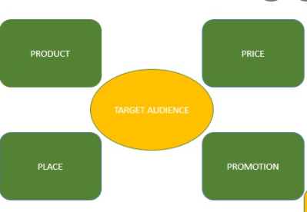

Product
Hydro-Tsuki filters use the reverse osmosis technique in which water is passed under pressure through a semi-permeable membrane to remove heavy metals such as arsenic, fluorides, nitrates, mercury and other dissolved impure salts.
It Filters up to 40,000 liters of water. Enough to provide clean drinking water for a family. Eliminate at least 99.99% of viruses. Eliminate at least 99.99% of bacteria, protozoan cysts and micro plastics.

Price
This product is unique and implemented first time in the industry. Hydro-Tsuki is small in size and doesn’t consume electricity, which makes it very efficient. In the product, chemicals are used that kill 100% of germs and filter the water. We offer our product at an affordable price taking into account the needs of our customers. It costs only 1999 / - Rs. Since the production cost with all the equipment installed and used in the product cost 1100 for each product. Including 200 Rs for transportation charges an estimation of about 1400 is the production cost of a product including all the labors and additional charges.
Keeping in view of that around 500 RS is considered the profit revenue of the product. The only time when price setting is not a problem is when you are a “price-taker” and has to set prices at the going rate, or else sell nothing at all. This normally only occurs under near-perfect market conditions, where products are almost identical. The pricing decisions for this product are among the most difficult that we as a business had to make for customers in different locations and countries.

Place
In countries like Brazil and Pakistan, including other countries like Niger, India and chad is considered where there is a shortage of clean water and people are facing serious water problems, our product will help them to eliminate those problems. It will allow them to drink clean water easily.
Wherever Hydro-Tsuki Industries cannot economically sell directly, due to distance or quantities, it will utilize a network of water service companies. These companies will be carefully chosen for their quality of service.
An arrangement will be set up whereby the distributor will offer DI exchange service along with its other water services. The installations can easily be handled by them. They would tag the tanks and return and pick up from the Hydro-Tsuki plant. Being able to offer this service increases the image of the local water service company. It fosters a feeling a one-stop shopping. A 33% discount off the retail price should be adequate to satisfy the distributors

Promotion
We are donating a product on the purchase two products. Besides, we also go to the target market to promote our product.
The main focus of promotion will be two-pronged: promotion to Hydro-TsukiIndustries end users, and promotion to wholesalers. Promotion to wholesalers should receive primary stress due to the extended reach made possible by the wholesaler network with its existing customer base.
The sales force of these wholesale distributors needs to be educated on Hydro-Tsuki positioning statement so that they all understand the important sales advantages of segregated resin. Being able to offer DI exchange service to a distributor's customer list is a great advantage to the distributor, and this fact needs to be clearly spelled out to them.
Therefore, the Hydro-Tsuki relationship with a dealership network is one in which both sides benefit. Hydro-Tsuki should strive to create a small-town, friendly relationship with its customers. Company brochures will show a map with all the Hydro-Tsuki locations, including each newly acquired distributor. The distributor trucks, as well as Hydro-Tsuki vehicles, would carry the Hydro-Tsuki logo, helping all to achieve name recognition. Cost savings would result through sharing literature, leads (by territory and/or industry), co-op marketing costs, and the sharing of technical expertise.

Business Analysis

Promotional budget

Sales Forecast
 | 2018 | 2019 | 202
Sales
Personal contacts | $39,091 | $77,854 | $82,547
Recurring revenue stream | $2,189 | $15,447 | $19,874
Total Sales | $41,280 | $93,301 | $102,421
Direct Cost of Sales | 2003 | 2004 | 2005
Personal contacts | $19,546 | $38,927 | $41,274
Recurring revenue stream | $0 | $0 | $0
Subtotal Direct Cost of Sales | $19,546 | $38,927 | $41,274

Projected income statement for 03 years

General Assumptions
Plan Month | 1 | 2 | 3
Current Interest Rate | 05.00% | 05.00% | 05.00%
Long-term Interest Rate | 10.00% | 10.00% | 10.00%
Tax Rate | 22.49% | 25.00% | 25.37%
Other | 0 | 0 | 0

